ASSIGNMENT-3

|  |  |
| --- | --- |
| Assignment Date | 07 October 2022 |
| Student Name | UMADEVI.M |
| Student Roll Number | 311019104096 |
| Maximum Marks | 2 Marks |

# Question 1:

Create a bucket in IBM object storage.

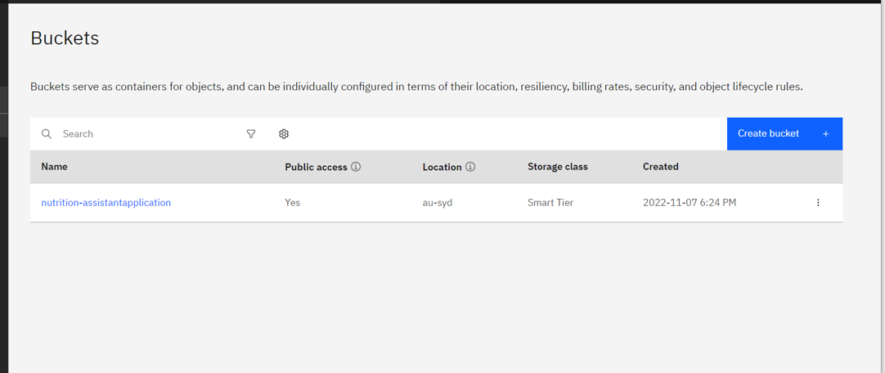

**Question 2:**

Upload any 5 images to IBM object storage and make it public. Write HTML code to displaying all the 5 images

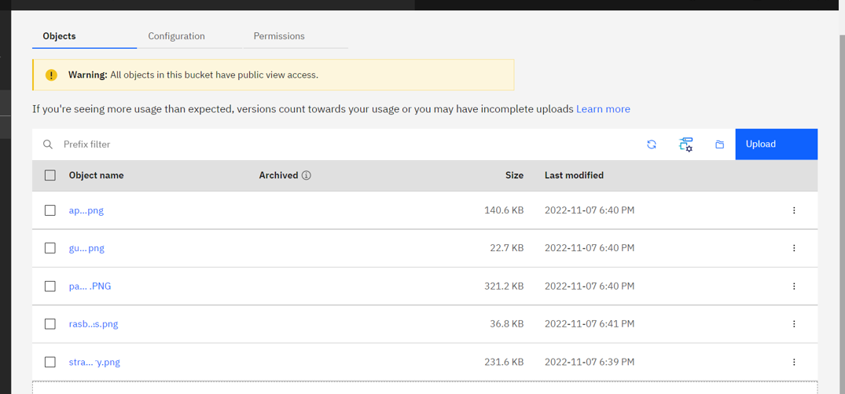

HTML code for displaying images in cloud

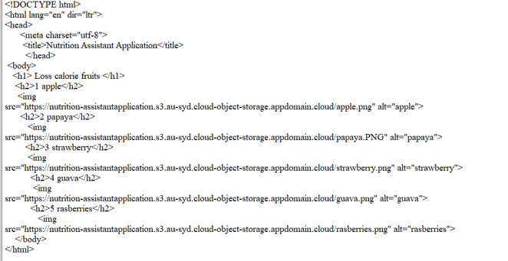

HTML Output for displaying images from IBM cloud storage:

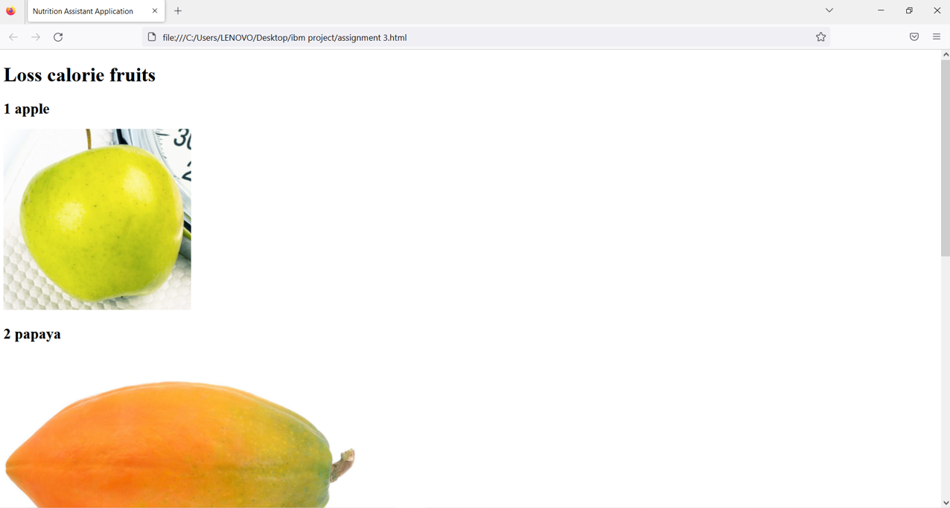

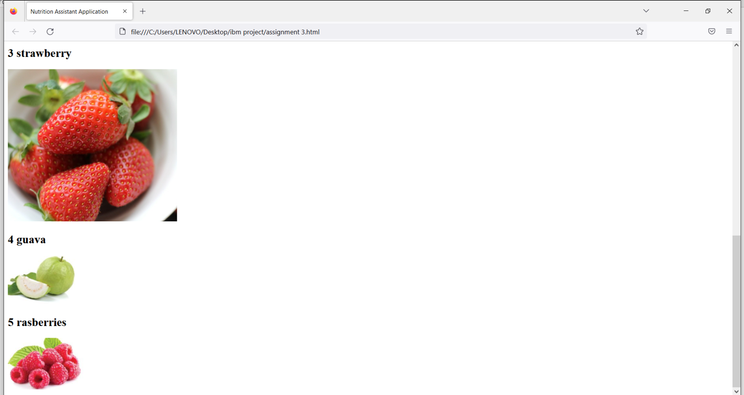

**Question 3:**

Upload a CSS page to the object storage and use the same page in your HTML code.

HTML code with CSS ﬁle present in IBM cloud storage:

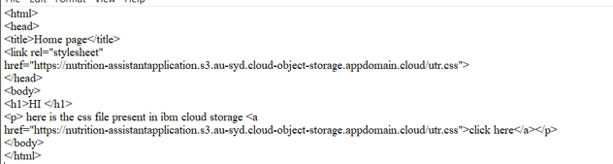

HTML code output:

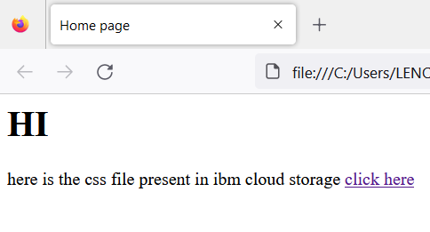

CSS ﬁle in Cloud object storage

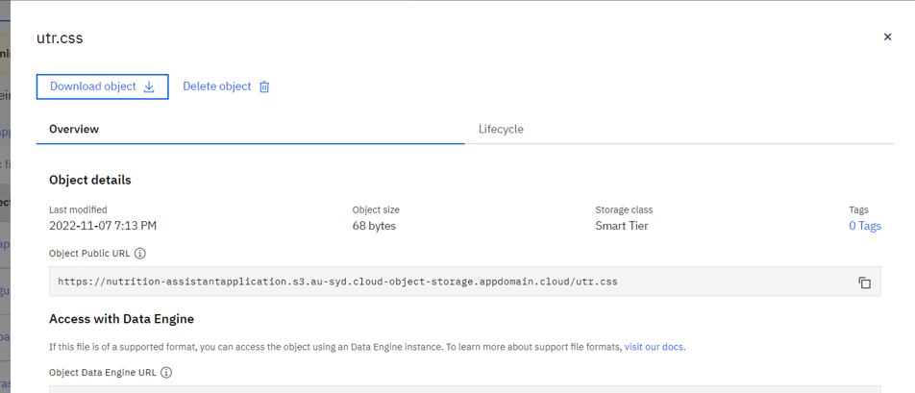

**Question 4:**

Design a chatbot using IBM Watson assistant for hospital. Ex: User comes with query to know the branches for that hospital in your city. Submit the web URL of that chat bot as a assignment.

**URL :**

[https:*/* web-chat.global.assistant.watson.appdomain.cloud/preview.html?ba](https://web-chat.global.assistant.watson.appdomain.cloud/preview.html?backgroundImageURL=https%3A%2F%2Fjp-tok.assistant.watson.cloud.ibm.com%2Fpublic%2Fimages%2Fupx-f3a1f015-5572-4204-96b6-7c25f885ddc6%3A%3A156bcb72-665e-46b3-872e-a17217657433&integrationID=d2b53d34-6e0e-4d81-b157-ae1023cd641a&region=jp-tok&serviceInstanceID=f3a1f015-5572-4204-96b6-7c25f885ddc6) [ckgroundImageURL=https%3A%2F%2Fjp-tok.assistant.watson.cloud.ibm.co](https://web-chat.global.assistant.watson.appdomain.cloud/preview.html?backgroundImageURL=https%3A%2F%2Fjp-tok.assistant.watson.cloud.ibm.com%2Fpublic%2Fimages%2Fupx-f3a1f015-5572-4204-96b6-7c25f885ddc6%3A%3A156bcb72-665e-46b3-872e-a17217657433&integrationID=d2b53d34-6e0e-4d81-b157-ae1023cd641a&region=jp-tok&serviceInstanceID=f3a1f015-5572-4204-96b6-7c25f885ddc6) [m%2Fpublic%2Fimages%2Fupx-f3a1f015-5572-4204-96b6-7c25f885ddc6](https://web-chat.global.assistant.watson.appdomain.cloud/preview.html?backgroundImageURL=https%3A%2F%2Fjp-tok.assistant.watson.cloud.ibm.com%2Fpublic%2Fimages%2Fupx-f3a1f015-5572-4204-96b6-7c25f885ddc6%3A%3A156bcb72-665e-46b3-872e-a17217657433&integrationID=d2b53d34-6e0e-4d81-b157-ae1023cd641a&region=jp-tok&serviceInstanceID=f3a1f015-5572-4204-96b6-7c25f885ddc6)

[%3A%3A156bcb72-665e-46b3-872e-a17217657433&integrationID=d2b5](https://web-chat.global.assistant.watson.appdomain.cloud/preview.html?backgroundImageURL=https%3A%2F%2Fjp-tok.assistant.watson.cloud.ibm.com%2Fpublic%2Fimages%2Fupx-f3a1f015-5572-4204-96b6-7c25f885ddc6%3A%3A156bcb72-665e-46b3-872e-a17217657433&integrationID=d2b53d34-6e0e-4d81-b157-ae1023cd641a&region=jp-tok&serviceInstanceID=f3a1f015-5572-4204-96b6-7c25f885ddc6) [3d34-6e0e-4d81-b157-ae1023cd641a&region=jp-tok&serviceInstanceID=f](https://web-chat.global.assistant.watson.appdomain.cloud/preview.html?backgroundImageURL=https%3A%2F%2Fjp-tok.assistant.watson.cloud.ibm.com%2Fpublic%2Fimages%2Fupx-f3a1f015-5572-4204-96b6-7c25f885ddc6%3A%3A156bcb72-665e-46b3-872e-a17217657433&integrationID=d2b53d34-6e0e-4d81-b157-ae1023cd641a&region=jp-tok&serviceInstanceID=f3a1f015-5572-4204-96b6-7c25f885ddc6) [3a1f015-5572-4204-96b6-7c25f885ddc6](https://web-chat.global.assistant.watson.appdomain.cloud/preview.html?backgroundImageURL=https%3A%2F%2Fjp-tok.assistant.watson.cloud.ibm.com%2Fpublic%2Fimages%2Fupx-f3a1f015-5572-4204-96b6-7c25f885ddc6%3A%3A156bcb72-665e-46b3-872e-a17217657433&integrationID=d2b53d34-6e0e-4d81-b157-ae1023cd641a&region=jp-tok&serviceInstanceID=f3a1f015-5572-4204-96b6-7c25f885ddc6)

Watso a Assistant —

Welcome, how can I assist you?

appointment booking

please select the preferred branch location

Delhi Numbai Chennai

ftotkata

Please select the preferred timing for appointment.

9:30 am 11:30 am 2:3O pm

5:00 pm

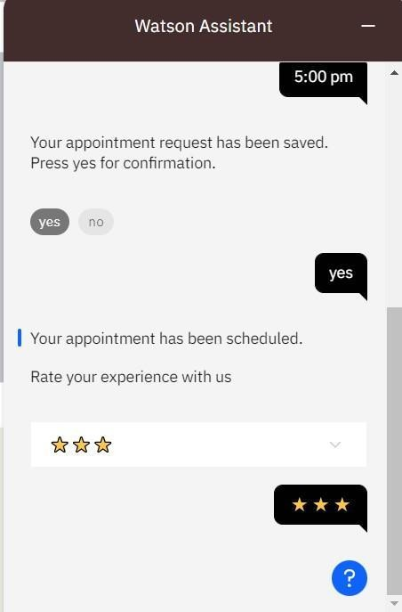

# Question 5:

Create Watson assistant service with 10 steps and use 3 conditions in it. Load that script in HTML page.

Script in HTML page:

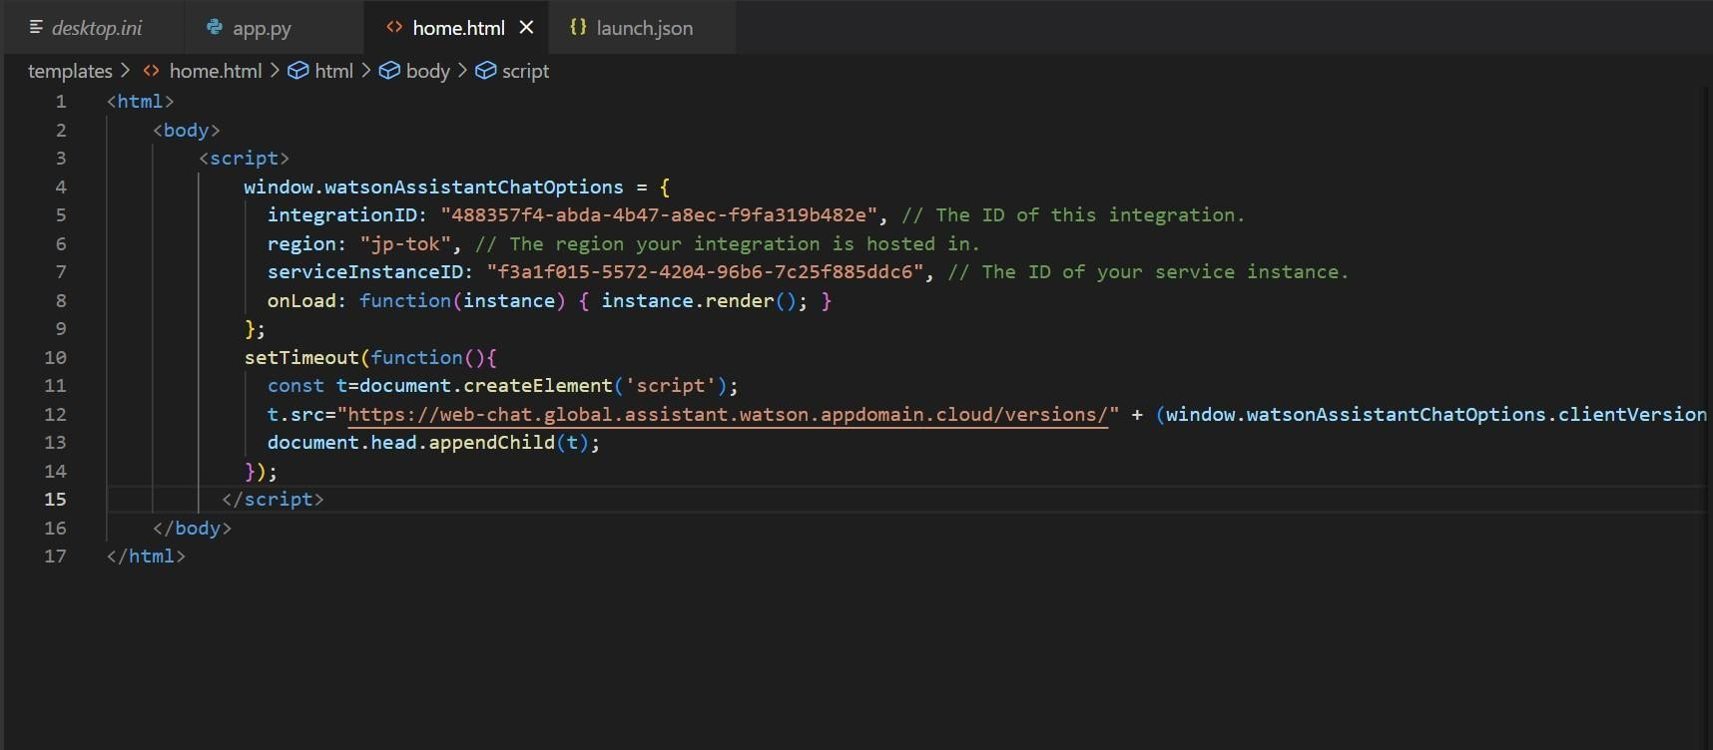

Food-ordering bot:

## Watson Assistant —

Welcome, how clan I assist you?

order food

### Select the food item









Watson Assistant —

## For delivery we yvill need a few pieces of information. Let me guide you through this process!

#### First, please provide your first name.



Thanks! Now, enter your last name.



Awesome. I’llatso need an email address associated with your new account. We will send you the delivery details to your email

Which email address would you like to use?



Watson Assistant —

## Enter the delivery location

Karappakkam ,Chennai

We need your i›hone nunbcr to contact you. Would you like to do so?

#### Yes, I'd like to add a phone numbers

Yes, I'll like to add a i›hone number.

O kay, please enter your phone number below.

9892441547

Watson Assistant —

Please enter a valid id.



9454675497

T hands! Docs the folloWi ng information look correct? If so, I Will proceed a•itI1 placing your order

* Name: xyzabc
* Email Address: xyzabc@gmail.com
* Phone Number: 9454675497
* Delivery Location: karapkkam,chennai



## Watson Assistant

### Email Address: : xyzabc@gmail.com

* Phone Number: 9454675497
* Delivery Location: Karappakkam,Chennai

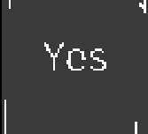

#### Your order will be uclivcred withi n 3 0 mins ! You will receive an cmai I cont rmation shortly.

We SCO 0!